GRANTH CHAUHAN CSE – B
Submission Evidence Submit the following:
1. GitHub repository URL - https://github.com/granth-alpha2/github-skills-challenge12.git
2 . Pull request URL used to validate the workflows - https://github.com/DebbieAUG/github-skills-challenge/pull/30
3. Screenshot showing the GitHub Actions workflows -
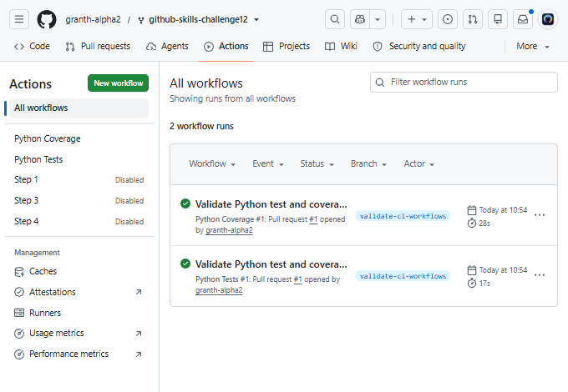
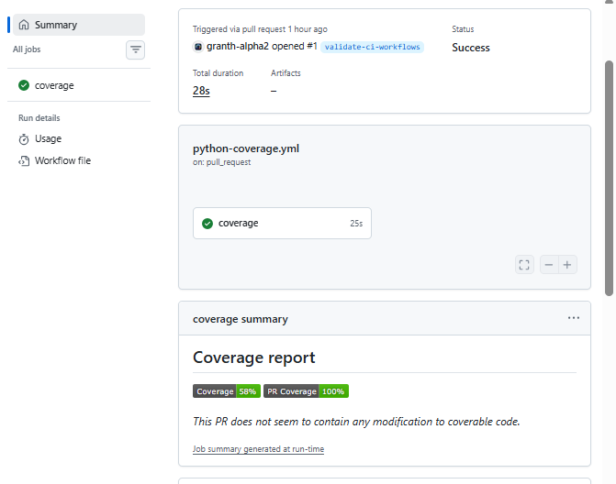
4. Screenshot showing a successful test workflow execution -
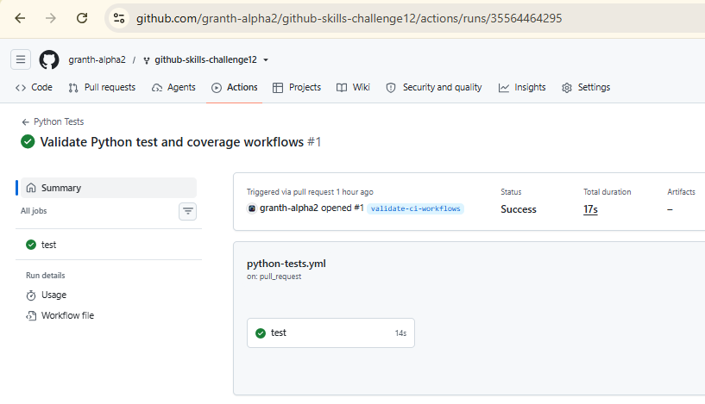
5.Screenshot showing the coverage result/comment on the pull request -
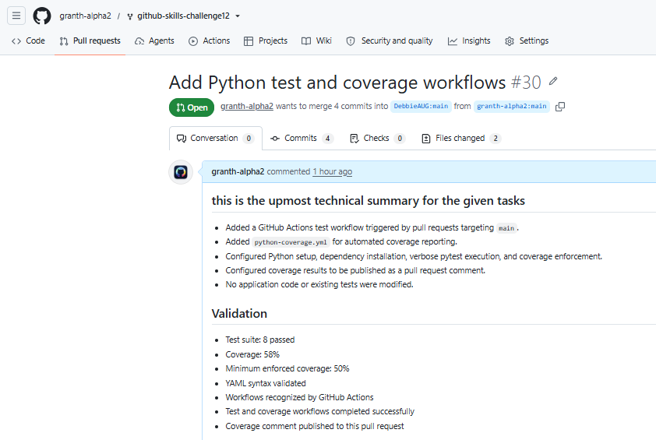
6. Screenshot showing the final repository/workflow files -
